DATA ANALYTICS

ASSIGNMENT 2

JAYESH SANA

Jayeshsana123@gmail.com

20KH1A0593

**DONUT CHART**

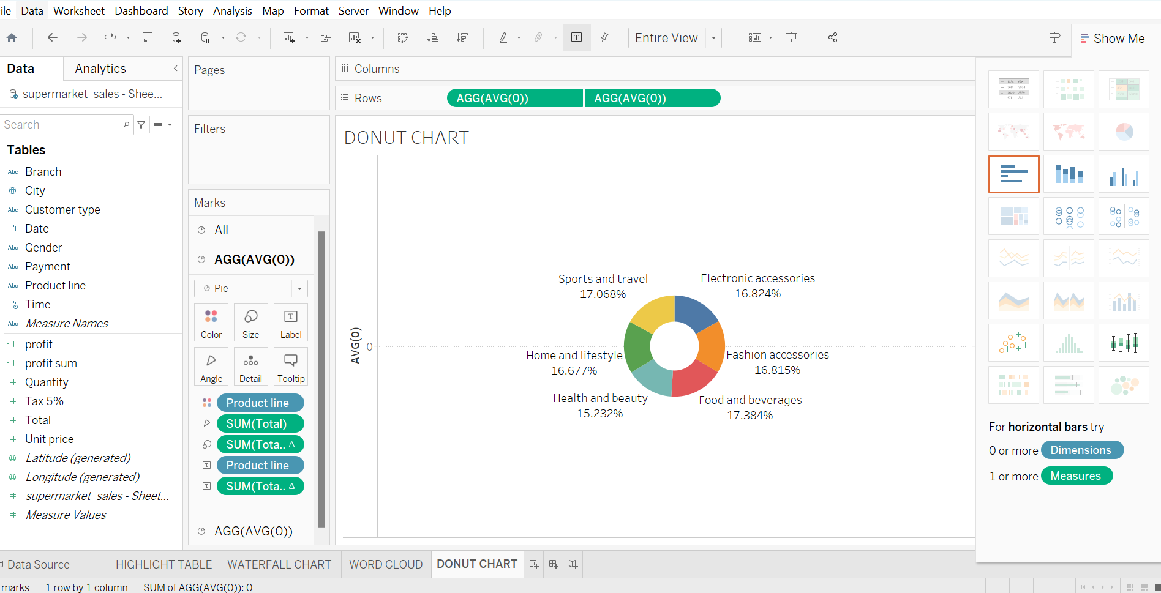

**AREA CHART**

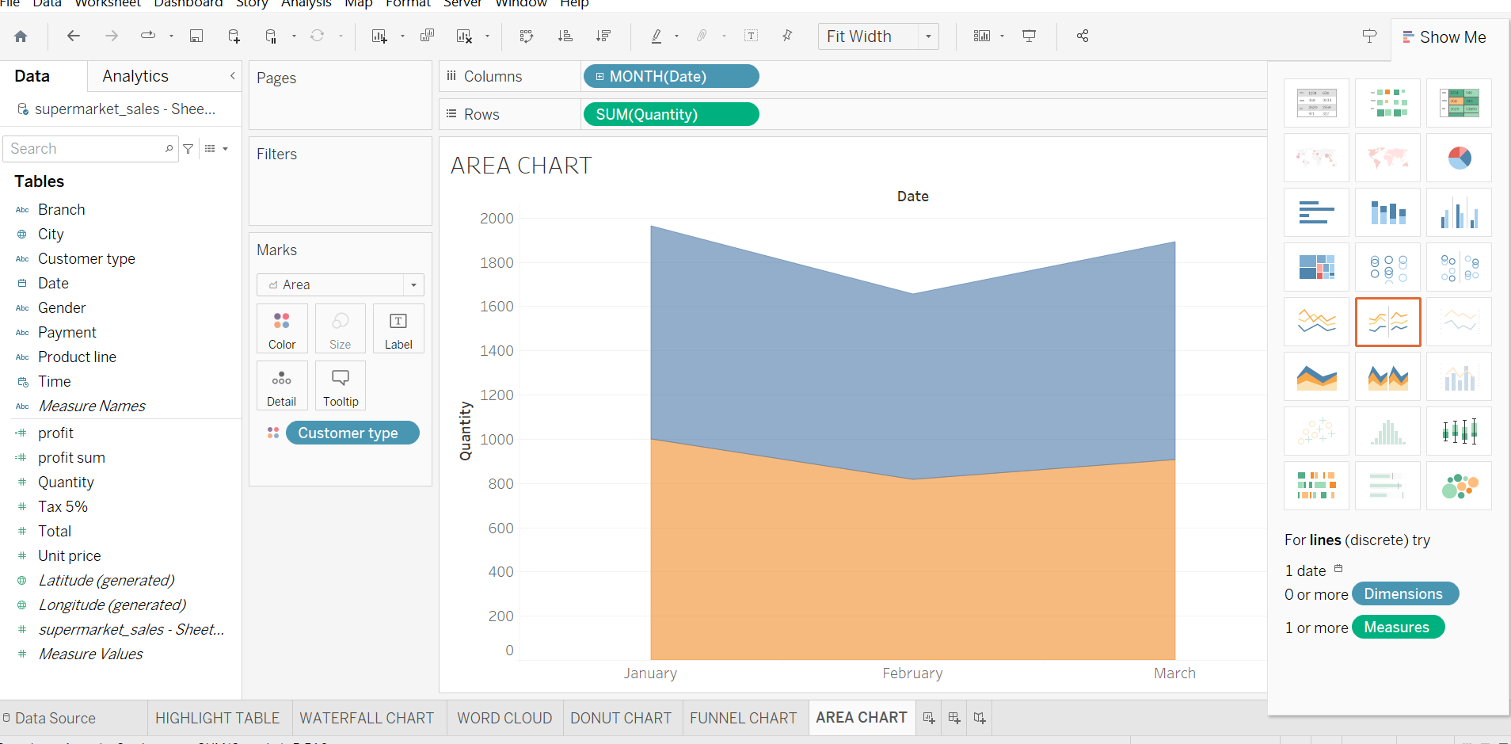

**TEXT TABLE**

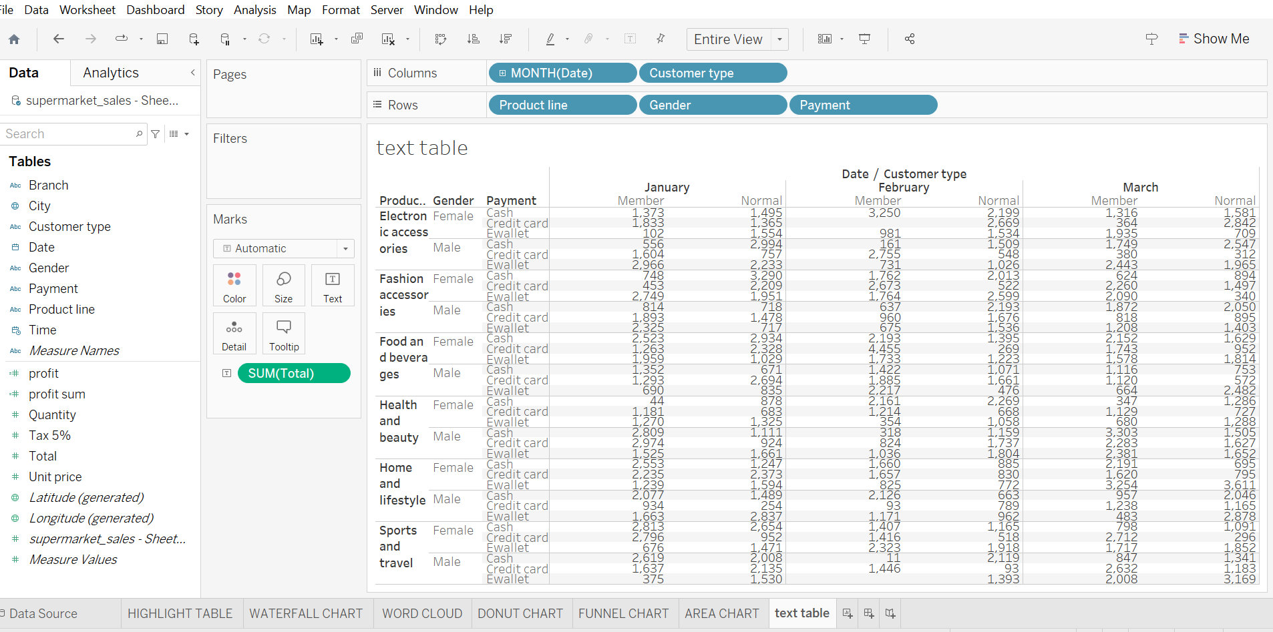

**HIGHLIGHTED TABLE**

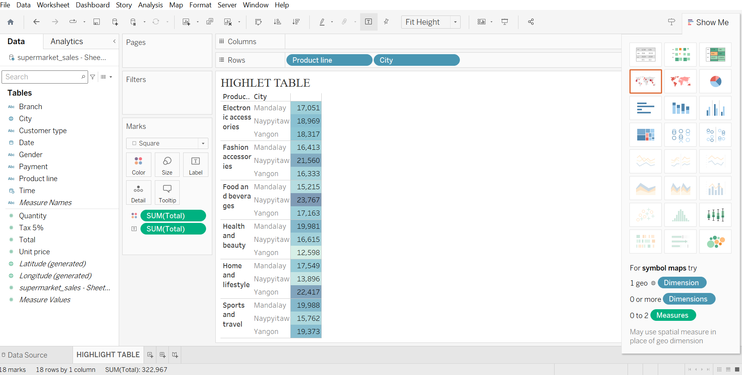

**WORD CLOUD**

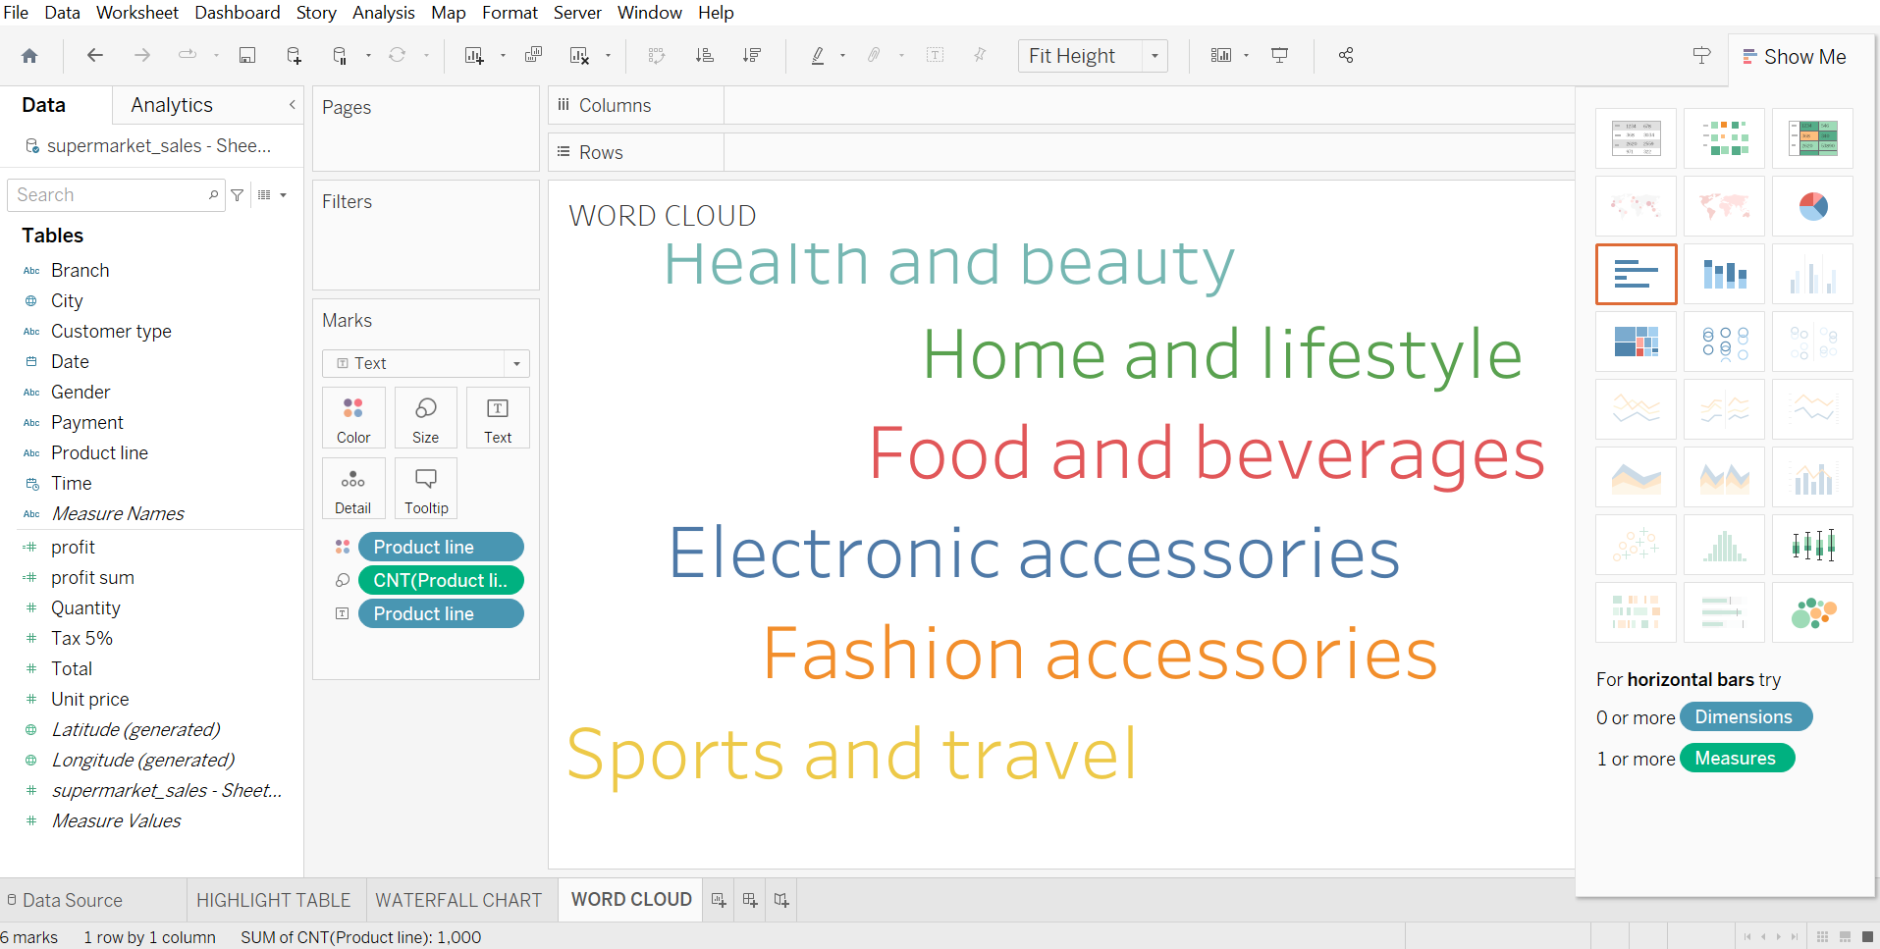

**FUNNEL CHART**

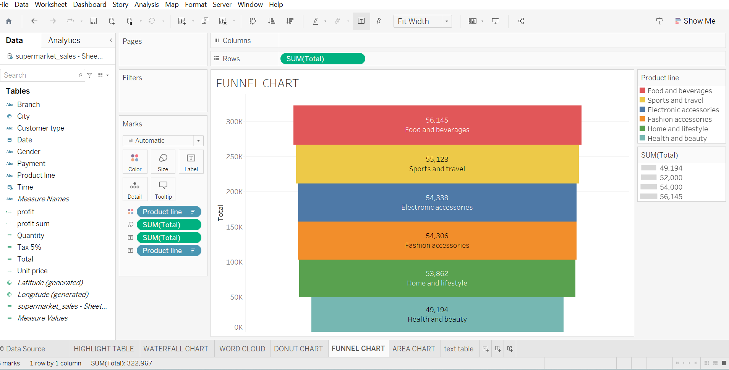

**WATER FALL**

